**Strange extra info on custom offer**

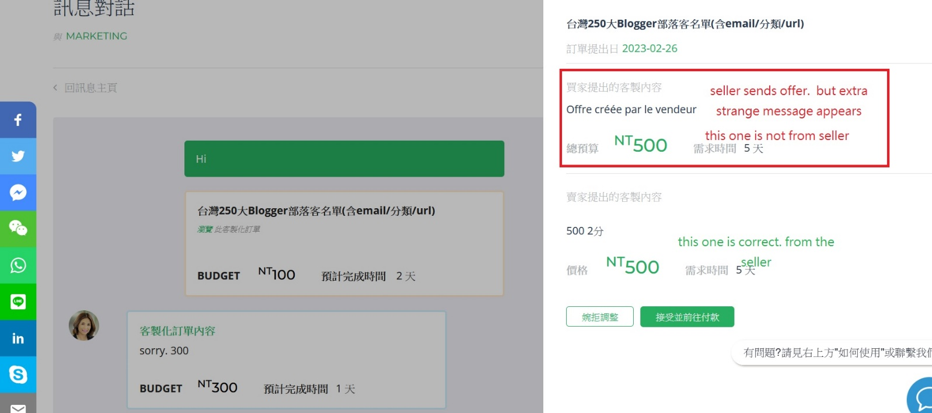

**Service name error on custom confirmation email notification**

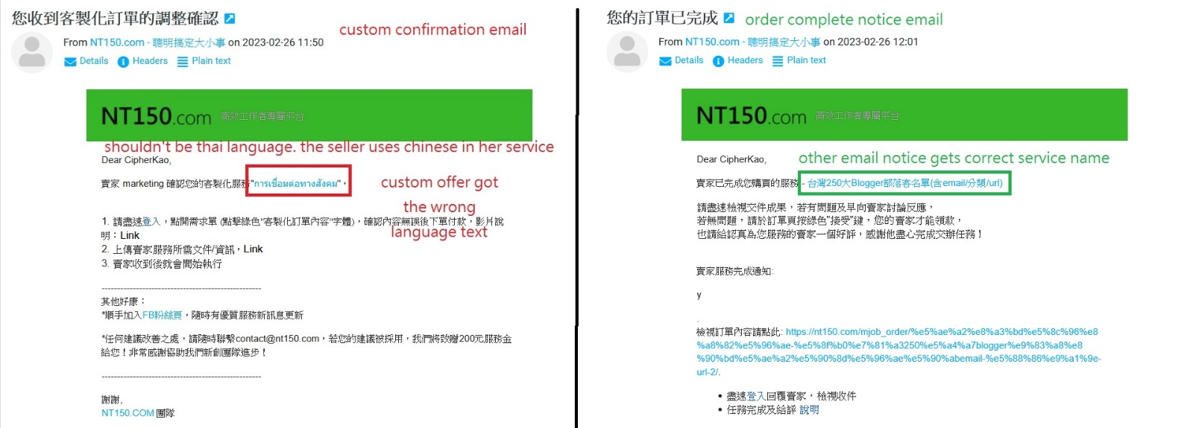

Still little parts are blue.

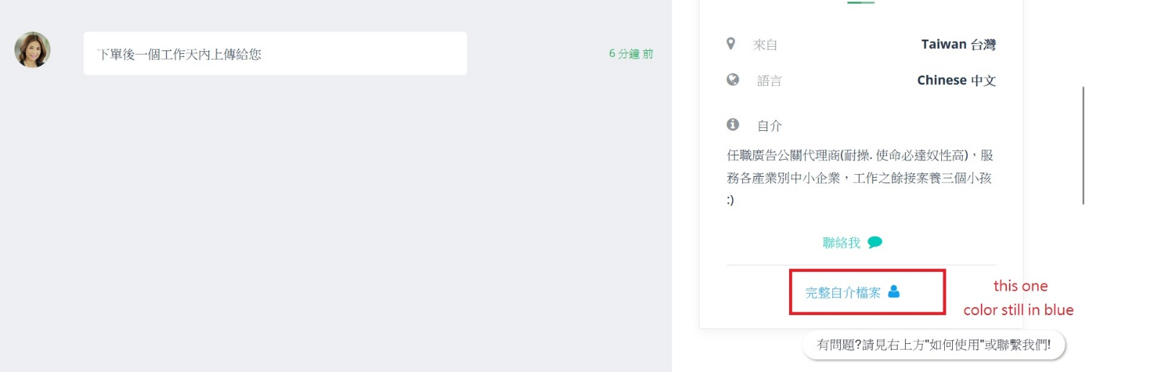

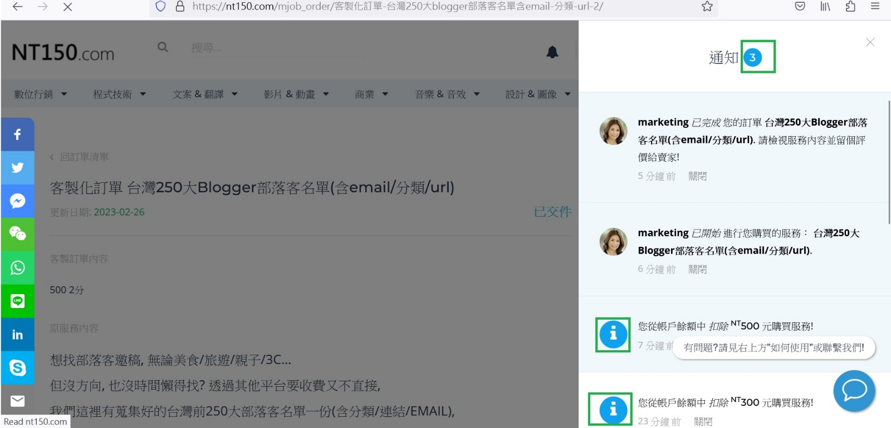

**Text adjustment. (My bad. Sorry)**

